Welcome to our Montana Mist Family!
We are really excited to introduce you to your new best friend! We have been getting ready for this day since your pup was born! We have put together this Puppy Packet to help make sure that the transition in bringing your new Montana Mist friend home is an easy and manageable one!
Nutrition and Your Puppy:
We are pleased to tell you we have started your puppy on the best nutrition we have ever found ~ Life’s Abundance. We have seen phenomenal results in our own breeding program ~ puppy litters are healthier and vigorous. Our nursing dams look fantastic and do not blow their coats after delivery. Also, our experience has been that the pups that continue with Life’s Abundance have fewer vet bills and get fantastic results with their bone and joint development as well as great overall health and longevity. This helps give insight why we are so passionate about this line of products, their quality and integrity. Congratulations and best wishes for years of good health, happiness and hugs!
Before picking up your puppy you have placed an order for the following: Life’s Abundance Extra Large Nutritional System. Your order should initially be set up on auto-ship for every 10 weeks...you can adjust these dates as your puppy matures. Because 60% of all canine hip dysplasia is related to poor nutrition, we require that your precious puppy continue with the Life’s Abundance Nutritional System for at-least the first 26 months of his/her life in order to qualify for our 2-year health guarantee. Remember, an ounce of prevention is worth a pound of cure!
I also highly recommend: Life’s Abundance Dental treats. These are important because this formula contains a variety of healthy whole grains, high-quality proteins plus hefty helpings of calcium and phosphorous, which are important nutrients for strong bones and teeth. These fantastic dental treats can be started when your puppy reaches 6 months of age.
We have gotten your puppy off to a great start by feeding him Life’s Abundance Premium holistic dog food! However, dogs are just like us, they can never get ALL their nutrition simply from the food they eat! This is why we so strongly recommend you feeding your puppy the Wellness Food Supplement and the Agility Formula! Supplementing your dog’s diet can play a crucial role in maintaining overall health and in the long run cost you fewer vet bills and add length of days to your puppy’s lifespan! The Agility Formula is important to us as we want to see you do everything possible to prevent your precious puppy from developing any hip or elbow related problems which are so common among Goldens! This formula helps maintain healthy joint cartilage and connective tissue, and to aid in the production of healthy synovial fluid, which lubricates the joints. Your puppy can also enjoy the variety of healthy, great-tasting treats you can sample from www.lifesabundance.com! These yummy products are uniquely formulated by our company veterinarian, Dr. Jane Bicks, to support good health through wholesome and nutritious ingredients.
We are so confident in Life’s Abundance Pet Foods and Supplements that we are offering a 2 Year Hip Guarantee against genetic moderate or severe hip dysplasia, and retinal eye disease. Should you choose this, the 2 year guarantee stipulates that the puppy must be fed Life’s Abundance Nutritional System for their first 26 months of life. The Agility Formula may also be given starting when the puppy is 6 months old. Our goal is to provide you the most superior pup possible in the best of health so that you can enjoy his companionship and love for MANY years to come!
Puppy Obedience Classes:
Also, because we have personally seen the dramatic, positive results that proper training of your new puppy brings, we require that you enroll your new puppy in our popular and very successful Puppy Academy 8 Week Online Puppy Training Course. Because you are a valued Montana Mist family member, we are giving you free access to this amazing program with Dog Trainer/Instructor Cara Putnam.
Check your inbox from Business Coach 365 giving you access to this training program! Once you set your password you will have access to this amazing training program!
So, give your Puppy a head start in life with the revolutionary Puppy Academy! This program is the ideal remedy to the age-old problem of the “16-week loss”! With the Puppy Academy, you can have a great big head start on your puppy's training schedule. The Puppy Academy is 100% at home and can be used on a frisky 8-week-old puppy who hasn’t had its 16 week vaccinations yet!!
Safely train at home during this period!
With the Puppy Academy you will NOT get a lot of hype and false promises, but here is what you WILL get:
- 8 WEEK ONLINE DIGITAL COURSE DEDICATED TO BASIC, LIFE SAVING AND ADVANCED SKILL COMMANDS
- HIGH QUALITY TRAINING VIDEOS THAT ARE FUN AND HELPFUL
- 35 TRAINING AND PROBLEM-SOLVING POWER POINT VIDEO PRESENTATIONS
- FREE BONUS TRAINING WEBINAR TEACHING YOU HOW TO SUCCESSFULLY POTTY TRAINING YOUR DOG IN AS LITTLE AS 6 DAYS!
- WEBINARS OF VARYING TRAINING TOPICS WITH OUR TOP DOG TRAINING EXPERTS. THIS WILL HELP GUIDE YOU STEP BY STEP THROUGH THE PROGRAM. GET ALL YOUR TRAINING RELATED QUERIES SOLVED AND ADDRESSED BY SOME OF THE BEST TRAINING AND BEHAVIOR EXPERTS IN THE BUSINESS!
- SELF PACED PROGRAM WHICH ALLOWS YOU TO TRAIN AND BOND WITHOUT ANXIETY OR PRESSURE.
- AN EASY END TO JUMPING, LEASH PULLING, BARKING, CHEWING AND OTHER TOP TRAINING ISSUES
- THIS COURSE WILL PREPARE YOUR POOCH TO TAKE BOTH THE AKC PUPPY STAR TEST AND THE AKC CANINE GOOD CITIZEN TEST!
At the Puppy Academy, our motto is "Your Progress is Our Success". We have put every tool in place for you to succeed in training your new pup into the dog of your dreams!

Recommended Products:
Also recommend for your new puppies grooming needs is a Furminator Grooming Rake which you can buy locally at most any pet store. This Grooming Rake easily removes the dead undercoat with minimal cutting and damage to your puppies beautiful coat!

Feeding Recommendations for Your New Puppy:
Dog Food:
If you have ever owned a puppy in the past your puppy will not need as much food as you are used to. Life’s Abundance dog food is top quality food and is highly concentrated! Your puppy will require less feeding while gaining maximum absorption of the nutrients! Thus, less waste clean-up and smell for you!
The cost of Life’s Abundance All Life Stage Formula is comparable to other quality brands. A 40# bag of All Life Stage Formula will last your 8-week-old puppy 10 weeks and a full-grown dog 2 months. This makes your cost of feeding affordable at about $2.07 a day or $62.10 a month! That is less than you and I spend on a Starbucks coffee every morning and it is the best quality nutrition you can give your precious pet!
Currently your puppy will need 1/2 cup 3-4 times a day (depending on your puppies weight when they go home with you ~ refer to the feeding chart below). It is important to feed your new puppy about 3-4 times daily and be sure they always have access to fresh water.
Below is a chart of the recommending serving size for the Life’s Abundance All Life Stage Dog Food:
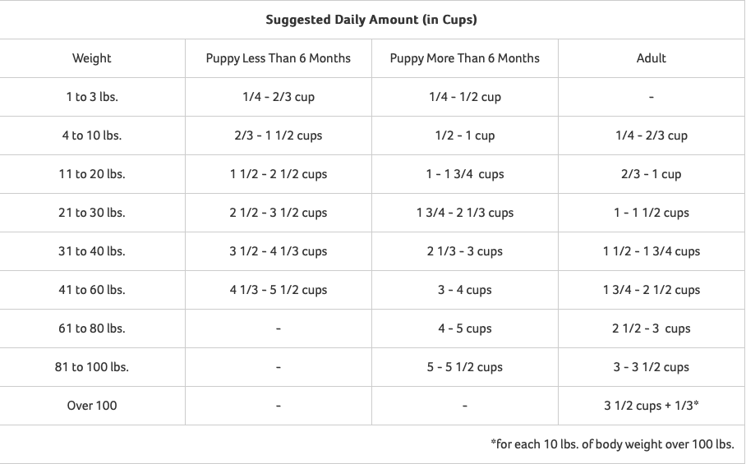

Serving size for Agility Supplement (Starting at 6 months of age):
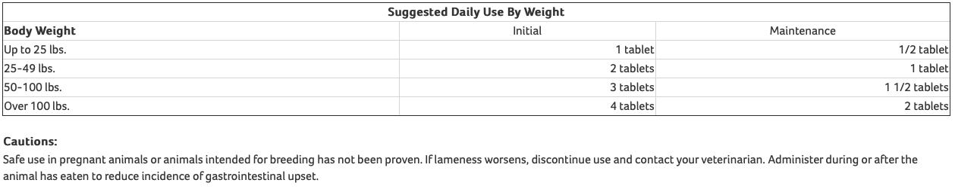
Serving Size for Wellness Supplements:
Recommended Daily Feeding For Your Dog:
Less than 20 lbs. | 1/2 tablet
20 - 40 lbs. | 1 - 1 1/2 tablets
40 - 60 lbs. | 1 1/2 - 2 tablets
60 - 80 lbs | 2 - 2 1/2 tablets
For each additional 20 lbs. add a 1/2 tablet.

Veterinary Care:
WORMING MEDICATION:
Your puppy is current on all worming medications when he comes home to you!

VACCINATIONS:
Your Puppy has had their 8 Week Vaccinations with us ~ We have given your puppy a Solo-Jec 5 Vaccination for Canine Distemper, Adenovirus Types 1 and 2, Parainfluenza and Parvovirus.
IMPORTANT: Your puppy’s vaccination schedule when they go home with you is:
- 12 Weeks: DHPP (5 Way Vaccination for Canine Distemper, Adenovirus Types 1 and 2, Parainfluenza and Parvovirus)

- 16 Weeks: DHPP (5 Way Vaccination for Canine Distemper, Adenovirus Types 1 and 2, Parainfluenza and Parvovirus) + Rabies
NOTE: Do NOT allow your vet to give your puppy any vaccination at 8 weeks! Your puppy has already had their 8-week vaccination with us and you do not want to over vaccinate and put your puppy at risk of pneumonia.

MICROCHIP INFORMATION
Your new puppy has been microchipped and has a glow in the dark tag with the microchip number on it! You will need to register your puppy’s microchip as soon as you get home with your new companion! Instructions for this are in your puppy care folder!
72 HOUR VET CHECK:
Be sure to have your puppy checked by a licensed veterinarian within 72 hours of purchasing this puppy! If the veterinarian determines at this time that there is a health problem in the puppy that cannot be rectified, then our health guarantee as listed in this packet applies!
Follow-Up
We have thoroughly enjoyed and been privileged to be the beginning of your precious puppy’s entrance to this world, and we are happy to be offering our new puppy owners only the very best! From veterinary care, to choosing only the highest quality food and supplements for your puppy, to giving your puppy loving, caring attention, we are happy to be sending your sweet puppy on to his next chapter in life…. joining and becoming a part of YOUR family! We hope you will enjoy your puppy for many years to come and we are available any time you need us for questions, support, or just to say hi! We hope you will send us pictures and updates of your puppy as he matures and develops! ☺
All the Best!
Judy Lowery (Owner of Montana Mist Goldens)
Phone: 406-721-9025
email: montanamistgoldens@yahoo.com

